
DMP Power BI Reports –
Water Act

User Guide
This publication is issued under the Open Government Licence – Alberta (http://open.alberta.ca/licence).

(Colophon, User Guide | Ministry of Environment and Protected Areas
© 2025 Government of Alberta | September 22, 2025


Contents
1. Context 1
2. Link 1
3. Water License Authorizations Report – Water Act 2
3.1 Water License Authorization Filters 2
3.2 Water License Allocation Filters 4
3.3 Clearing Filters Selected 5
3.4 Selecting Columns to Display in Report 7
3.5 Display Results Table 8
3.6 Export Data 9
3.7 Additional Functions in Report 10
4. Water License Applications Report- Internal 13
4.1 Search Filter parameters 13
4.2 Export Data 14
5. Water License Application and Authorization Report- Internal 15
5.1 Search Filter Parameters 15
5.2 Export Data 16
6. Water License Authorization Holder History Report 17
6.1 Search Filter Parameters 17
6.2 Export Data 22
7. Water License Level Measurements Report- Water Act 25
7.1 Search Filter Parameters 25
7.2 Export Data 25
8. Water License Quality Measurement Report- Water Act 27
8.1 Search Filter Parameters 27
8.2 Export Data 27
9. Water License Usage Measurements Report – Water Act 29
9.1 Search Filter Parameters 29
9.2 Export Data 30
10. Help 30

Context
This user guide presents the functionalities available in the DMP Power BI Reports for Water Act
The Power BI Reports allows users to find and view information relating to Water Licence (WL) applications, authorizations, Water usage, Level and Quality

Link
The Water Act Power BI Reports are available from most modern web browsers at: Power BI

Water License Authorizations Report – Water Act
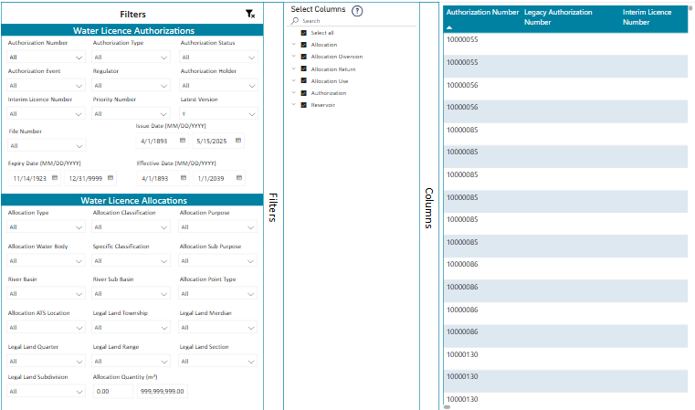

Water License Authorization Filters
User can search using one or more of the attributes from the Water License Authorization Filters
- Authorization Number- Allows searching by typing the Authorization Number OR using selecting from Dropdown
- Authorization Type – Dropdown
- Authorization Status – Dropdown
- Authorization Event – Dropdown
- Regulator- Dropdown
- Authorization Holder – Dropdown
- Interim License Number – Dropdown
- Priority Number – Dropdown
- Latest Version – Dropdown- by default only the Latest Y is shown
- File Number – Dropdown
- Issue Date – Select the Date Range
- Expiry Date – Select the Date Range
- Effective Date - Select the Date Range
If one or more filters are used in combination, the remaining attributes will only display the values based on the previous filters applied. For example, if user apply Search using ‘Authorization Holder’= BARRICK Energy Inc. and ‘Authorization Type’ = Temporary Diversion License, and then the filter ‘Authorization Number’ will only display Authorization Numbers held by BARRICK Energy Inc. which are Temporary Diversion License.

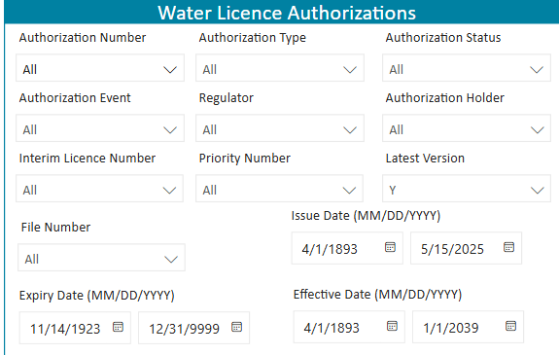

Water License Allocation Filters
User can search using one or more of the attributes from the Water License Allocation Filters:
- Allocation Type – Dropdown
- Allocation Classification – Dropdown- can be further drilled down into Sub- classifications using
the dropdown as shown below
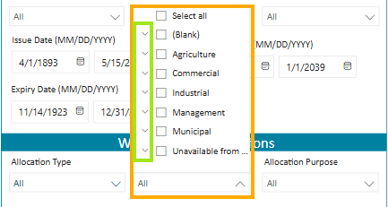

- Allocation Purpose – Dropdown
- Allocation Water Body – Dropdown
- Specific Classification – Dropdown
- Allocation Sub Purpose – Dropdown
- River Basin – Dropdown
- River Sub Basin – Dropdown
- Allocation Point Type – Dropdown
- Allocation ATS Location – Dropdown
- Legal land Township – Dropdown
- Legal land Meridian – Dropdown
- Legal Land Quarter – Dropdown
- Legal land range – Dropdown
- Legal land Section – Dropdown
- Legal Land Subdivision – Dropdown
- Allocation Quantity - Range
User may use a combination of filters from Water License Allocation and Water License Authorization filters to narrow down the query to a specific dataset. If one or more filters are used in combination, the remaining attributes will only display the values based on the previous filters applied.
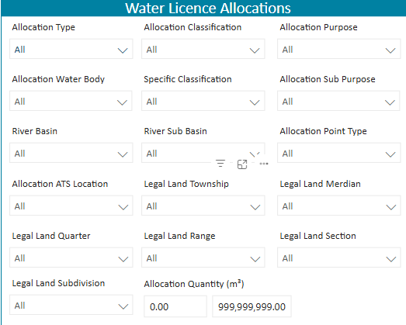

Clearing Filters Selected
At any point using the search filters, the user may clear a specific filter using the Clear selections as shown below. This will clear the selection applied to the selected filter attribute.
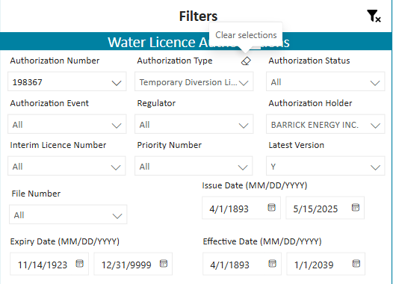
To clear all filters applied on the Power BI Report, the user may click on at the top right section of the Filters menu.
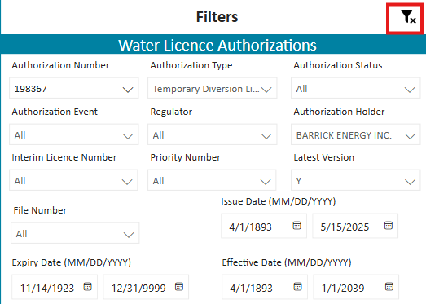

Selecting Columns to Display in Report
Power BI Report allows the user to choose the columns that need to be displayed. Selection of the columns to be displayed can be done using the Select Column Panel

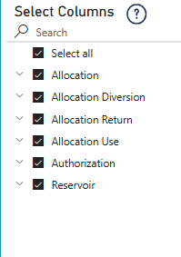
Columns are grouped under the following headings:
- Allocation
- Allocation Diversion
- Allocation Return
- Allocation Use
- Authorization
- Reservoir
Each group can be drilled down using the downward arrow
Click on the downward arrow against the heading to display the columns under the group and then use the checkbox to select the desired columns to be displayed in the Report.
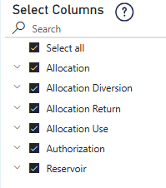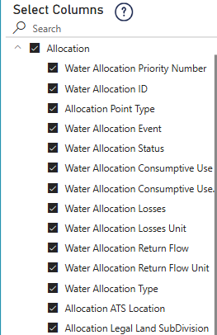

Display Results Table
Based on the attribute filters selected in the Search criteria, and the Columns selected to be displayed, the Report is displayed on the right. Click on any cell and scroll right or left to view all the columns in the Report.
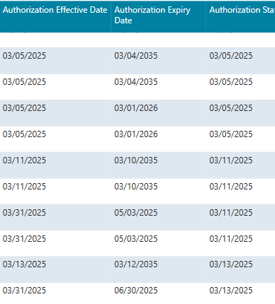
To display the Report on the full-page view, click on
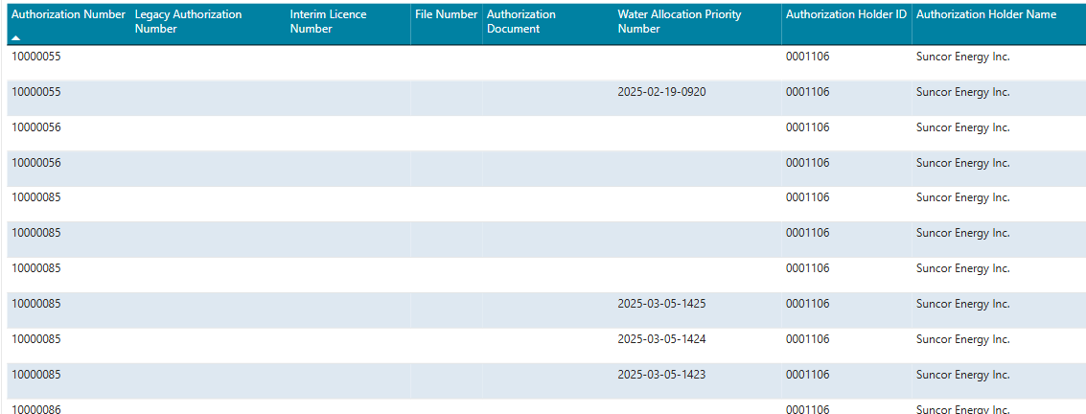
To return to the default view of the Report click on 

Export Data
Displayed data in the Table can be exported to Excel or .csv file for further analysis. This can be done using the steps mentioned below.
- Hover over the top right of the Report to look for the three dots. Click on the three dots to display the More options.
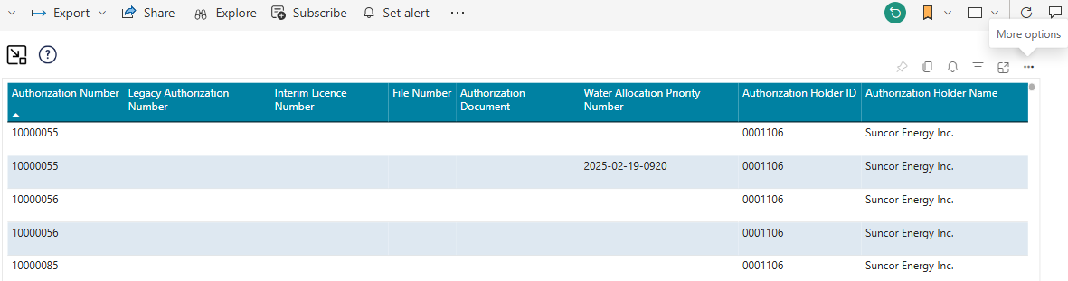
- Click on Export Data
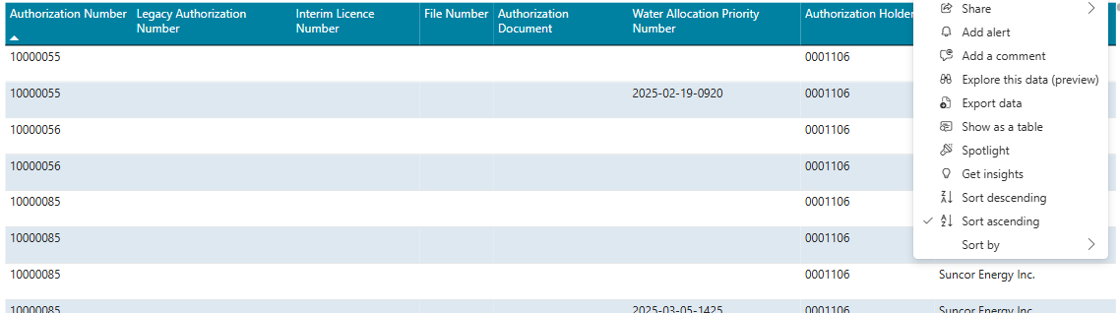

- Select> Data with Current Layout, and then Click on Export.
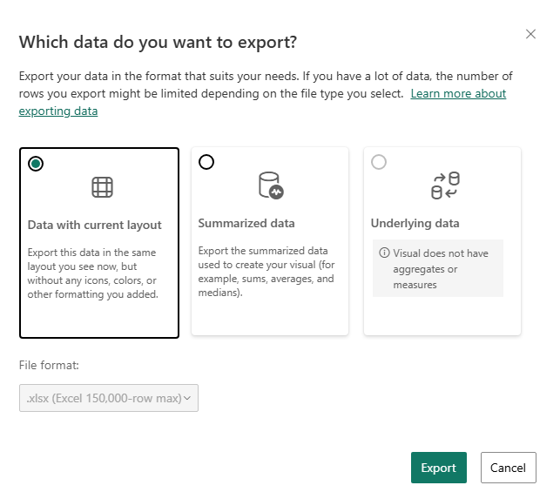

Additional Functions in Report

-  - Reset Filters, slicers and other data view changes user has made
- 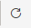 - Refresh Visuals, when the data model has been updated, refreshing will update all visuals with the latest data
- Ability to Sort Report display data - Hover over the top right of the Report to look for the three dots. Click on the three dots to display the More options> Sort Descending or Sort Ascending or Choose sort by any Column Name
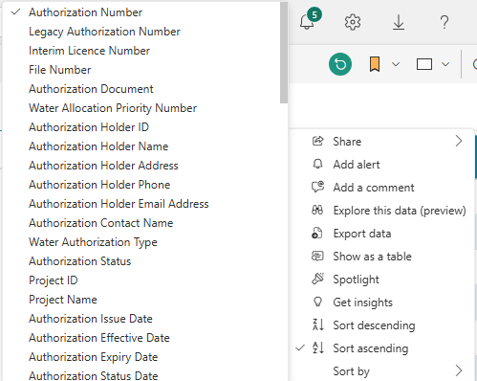
- Ability of Collapse Filters and Columns section – User can click on Filters or Columns to expose large real estate area to view the Results table. Clicking once will collapse the section. Clicking second time in the section will expand the section to return to the default view.
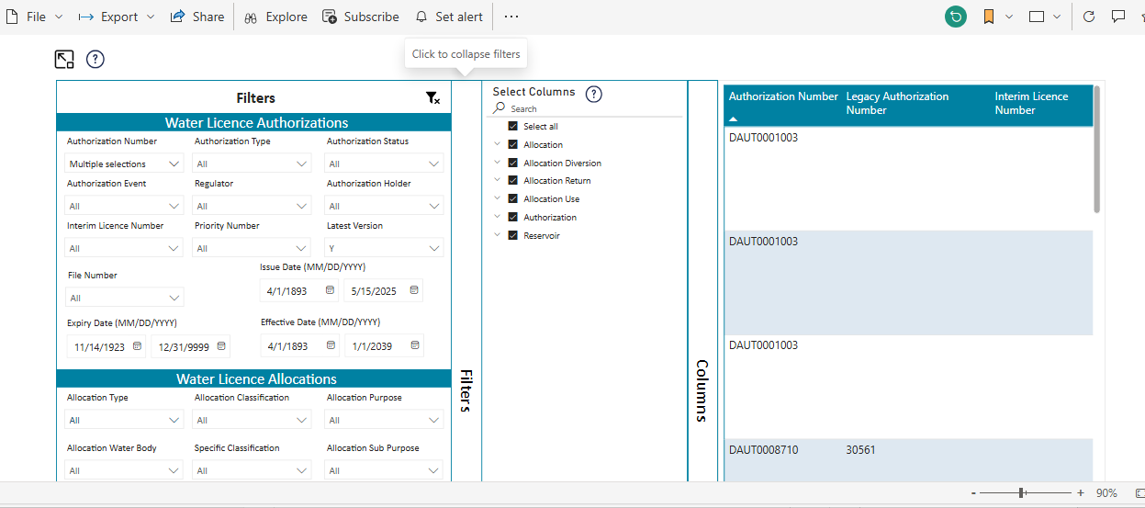
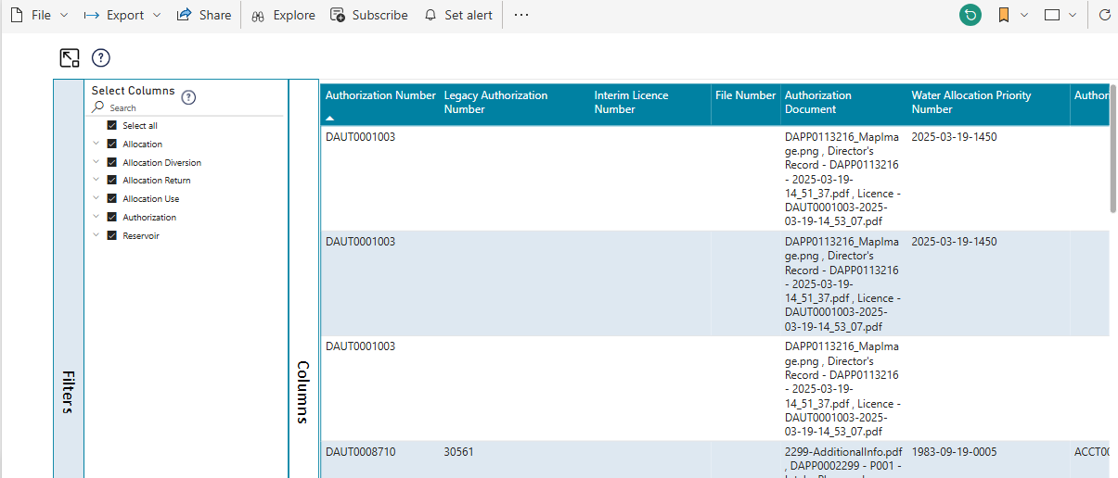
- Focus Mode- Click on the Focus mode will show the Results table in the full real estate of the screen. This will help better visualization of the data in the table. To return to the default view, click on Back to Report button at the top left

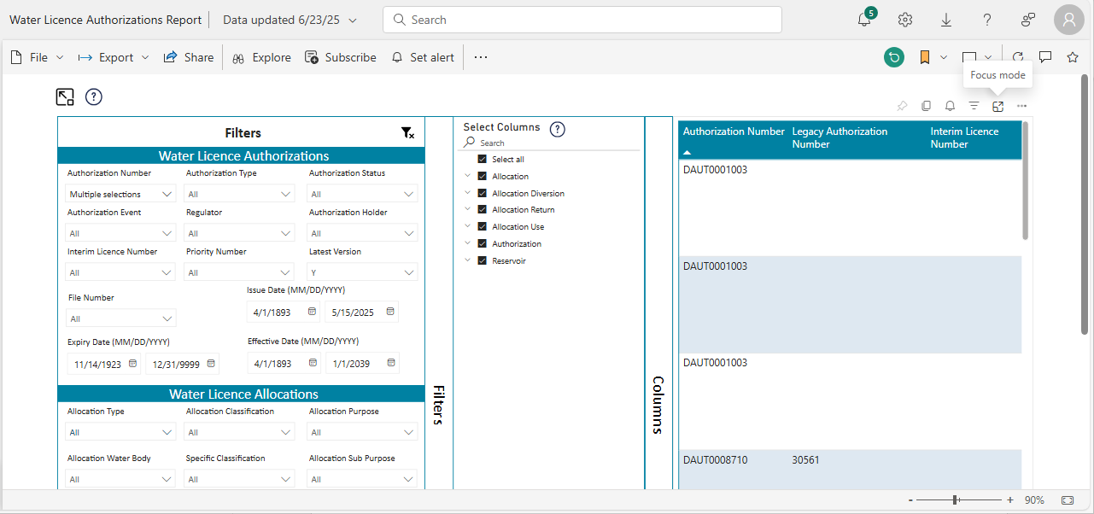

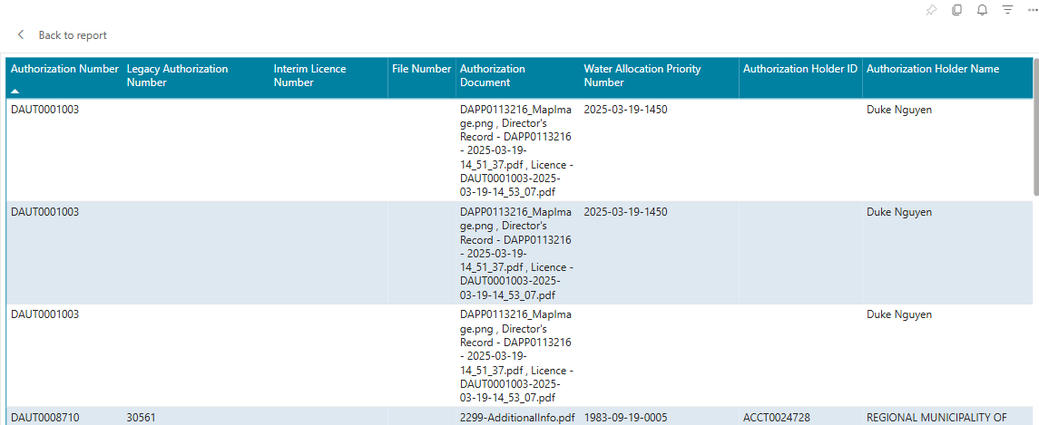

Water License Applications Report- Internal
This Report can be accessed in Production environment from the Power Bi Workspace: Water Licence Applications - Power BI
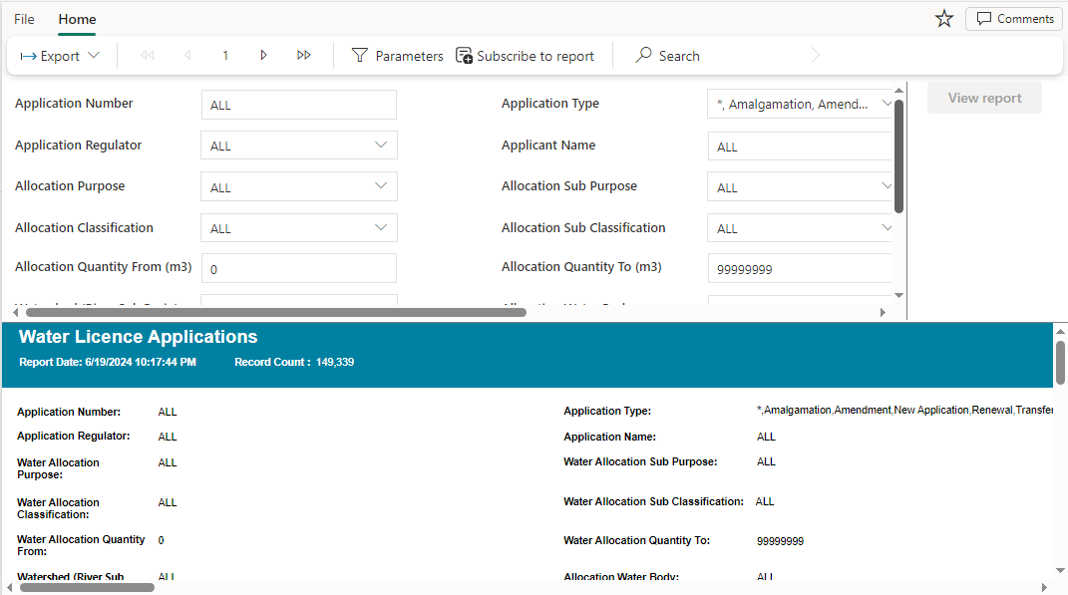

Search Filter parameters
User can search using one or more of the attributes from the Water License Application Filters
- Application Number – Text field
- Application Type – Dropdown
- Application Status – Dropdown
- Regulator – Dropdown
- Applicant Name – Text field
- Project Name – Dropdown
- Allocation Purpose – Dropdown
- Allocation Sub Purpose – Dropdown
- Interim License Number – Text field
- Allocation Classification – Dropdown
- Allocation Sub Classification – Dropdown
- Allocation Specific Classification – Dropdown
- Allocation Quantity – Range
- Allocation Type – Dropdown
- Watershed (River Sub Basin) – Text field
- Allocation Water Body – Text Field
- Latest Version Flag – Dropdown
Upon selecting one or more search filter parameters, the user must click on  button to display the Table of results.
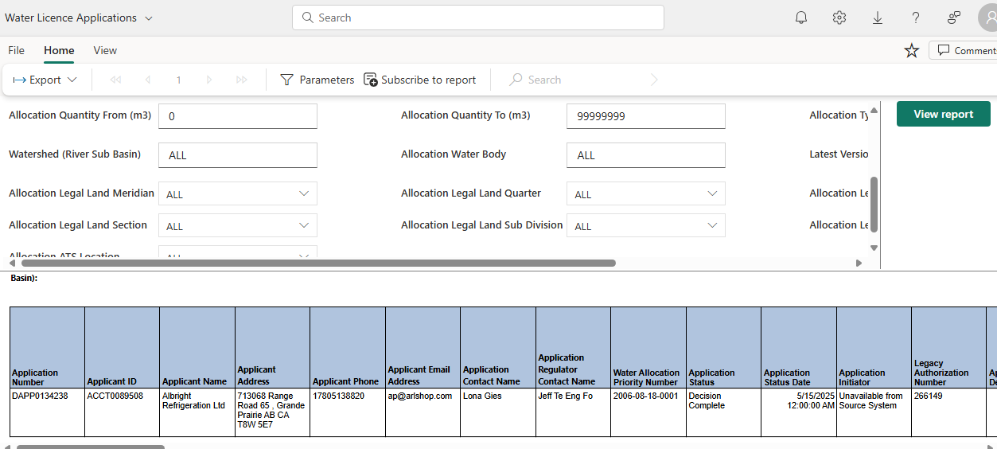

Export Data
Displayed data in the Table can be exported to Excel or .csv file for further analysis. This can be done using the steps mentioned below
- Click on Export Dropdown at the top left> Select Microsoft Excel or Comma Separated Values (.csv)

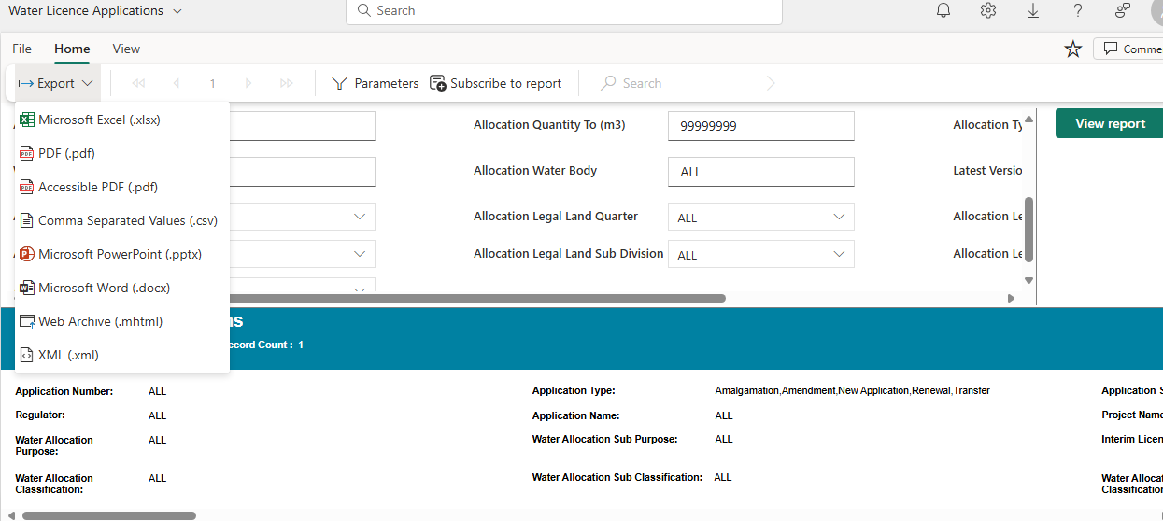

Water License Application and Authorization Report- Internal
This Report can be accessed in Production environment from the Power Bi Workspace Water Licence Applications & Authorizations - Power BI

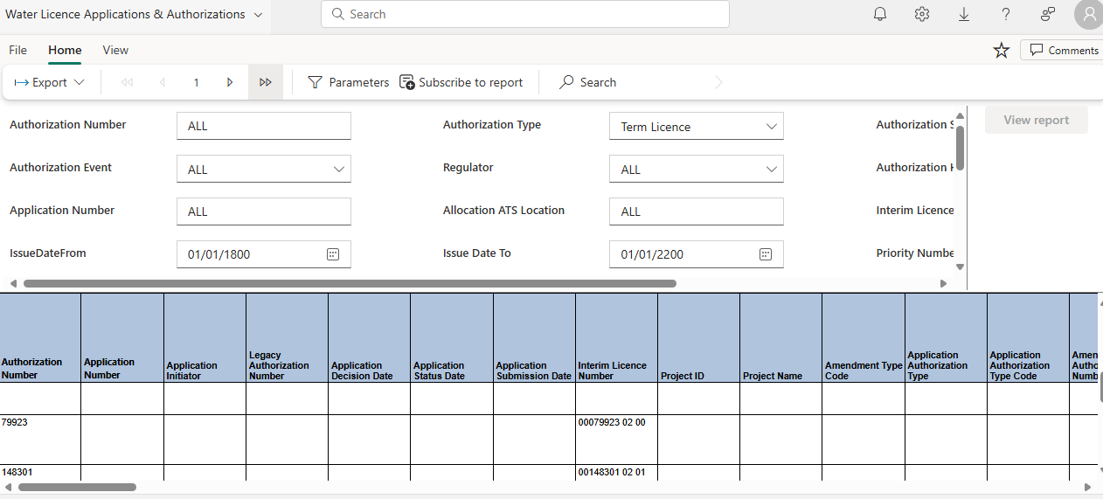

Search Filter Parameters
User can search using one or more of the attributes from the Water License Application and Authorization Filters
- Authorization Number – Text Field
- Authorization Type – Dropdown
- Authorization Status – Dropdown
- Authorization Event – Dropdown
- Authorization Holder – Text Field
- Allocation ATS Location – Text Field
- Application Number – Text field
- Regulator – Dropdown
- Issue Date – Range
- Expiry Date – Range
- Effective Date – Range
- Authorization Status Date - Range
- Priority Number - Dropdown
- Allocation Purpose – Dropdown
- Allocation Sub Purpose – Dropdown
- Interim License Number – Text field
- Allocation Classification – Dropdown
- Allocation Sub Classification – Dropdown
- Allocation Specific Classification – Dropdown
- Allocation Quantity – Range
- Allocation Type – Dropdown
- Watershed (River Sub Basin) – Text field
- Allocation Water Body – Text Field
- Latest Version Flag – Dropdown
Upon selecting one or more search filter parameters, the user must click on button to display the Table of results.
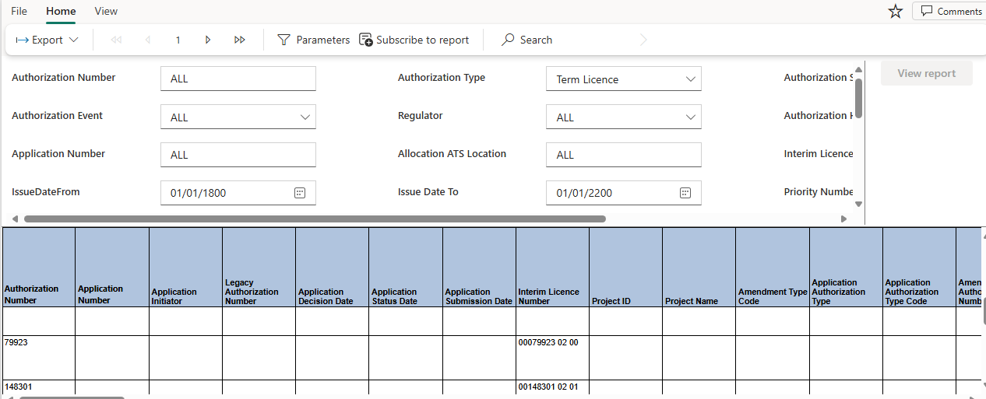

Export Data
Displayed data in the Table can be exported to Excel or .csv file for further analysis. This can be done using the steps mentioned below
- Click on Export Dropdown at the top left> Select Microsoft Excel or Comma Separated Values (.csv)
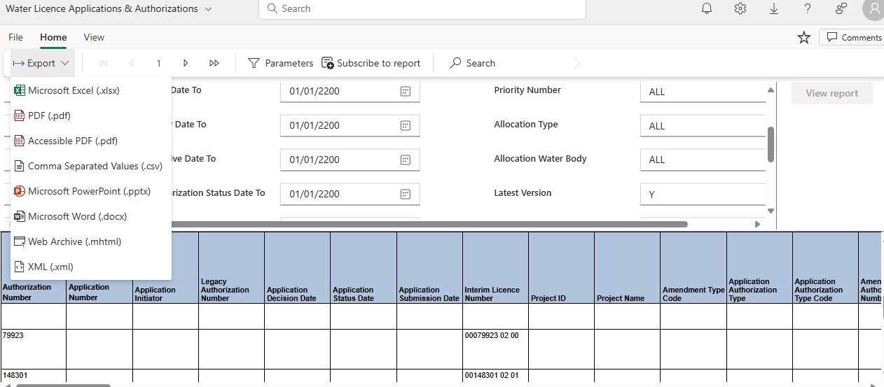

Water License Authorization Holder History Report
This Report can be accessed in Production environment from the Power Bi Workspace Search - Water Diversion Authorization Holder History - Power BI

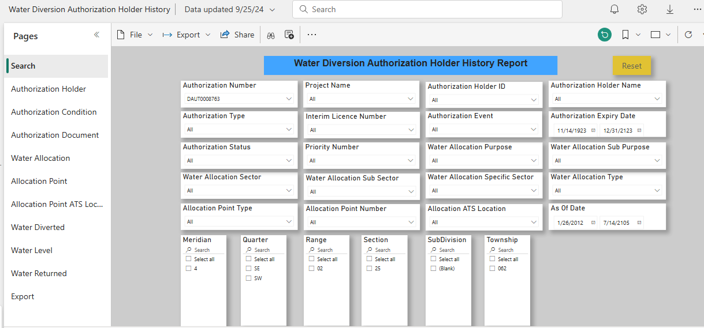

Search Filter Parameters
User can search using one or more of the attributes from the Search Page
Authorization Holder Page:
This page displays the History of Authorization Holders over time
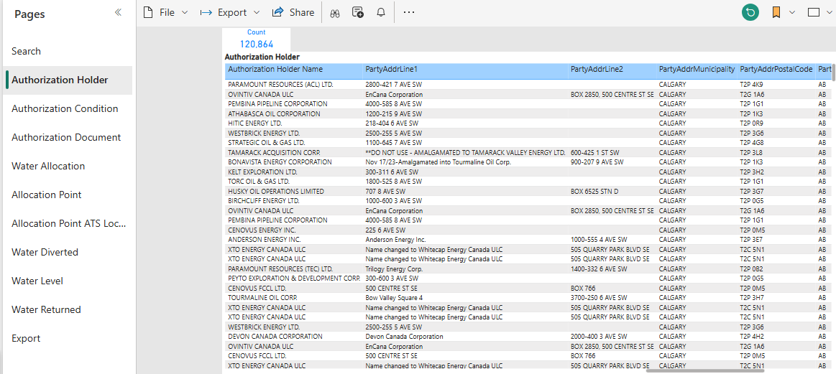
Authorization Condition Page:
This page displays the History of Authorization conditions over time
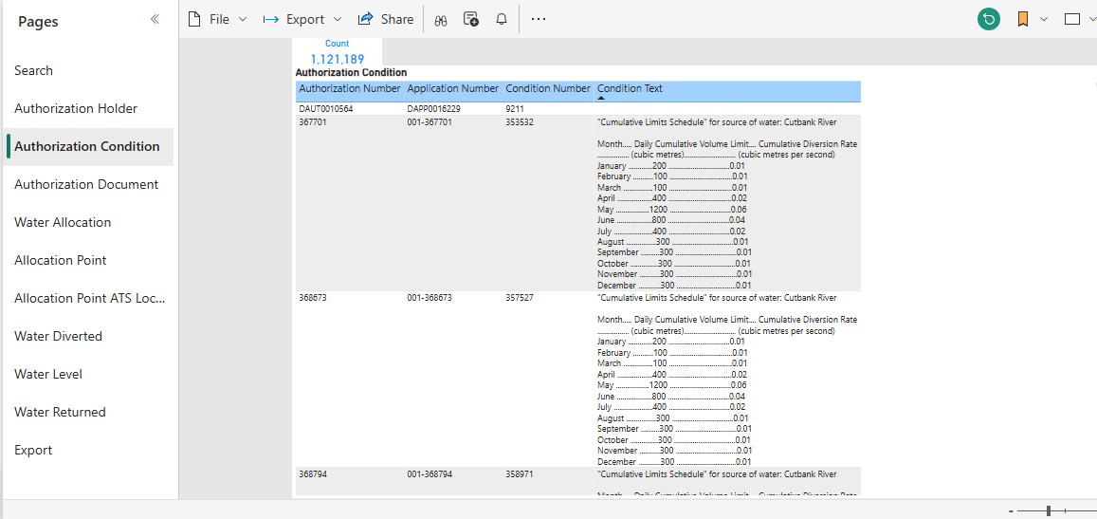
Authorization Document Page:
This page displays the History of Authorization documents over time
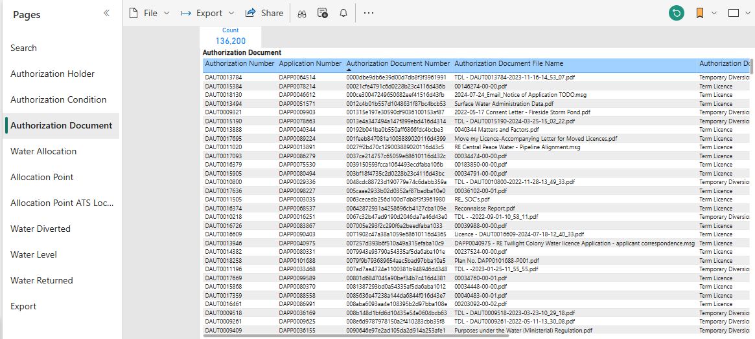
Water Allocation Page:
This page displays the History of Water Allocations over time

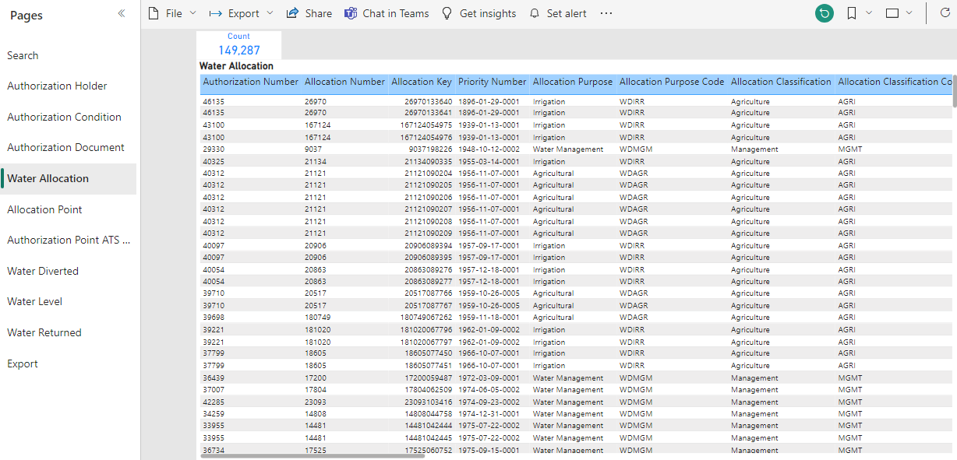
Allocation Point Page:
This page displays the History of Water Allocation points over time
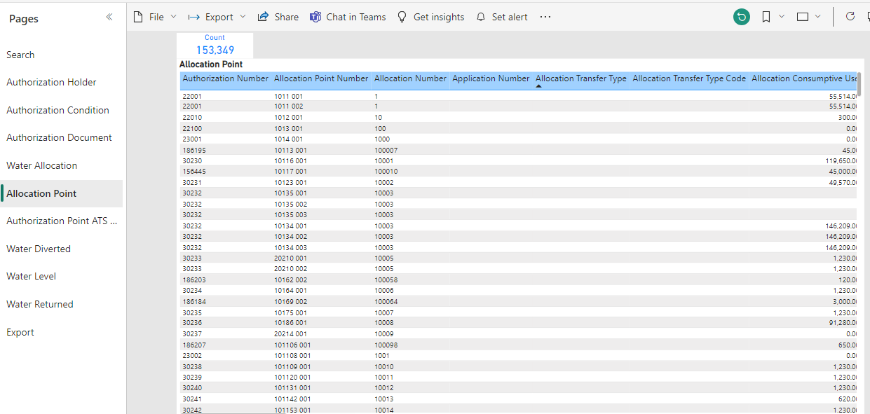
Allocation Point ATS Locations Page:
This page displays the History of Water Allocation point ATS Locations over time
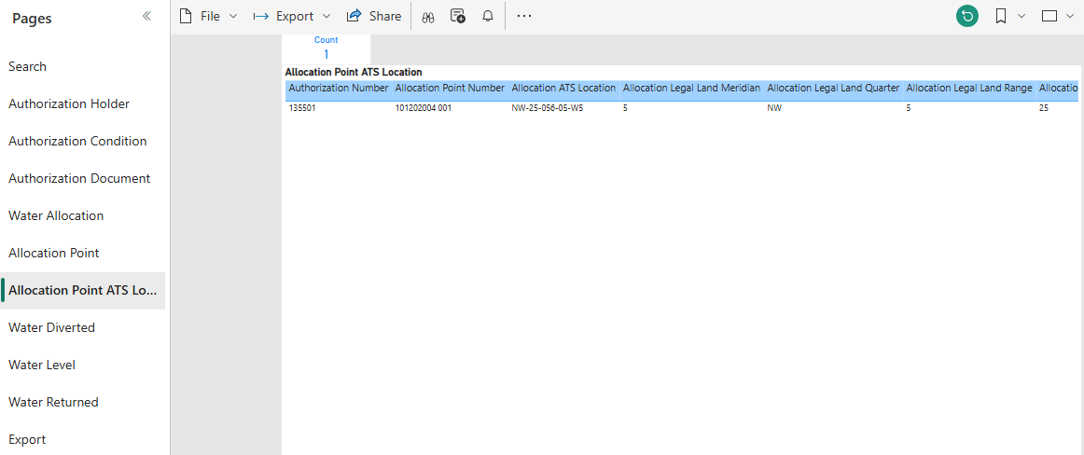

Water Diverted Page:
This page displays the History of Water Diverted over time
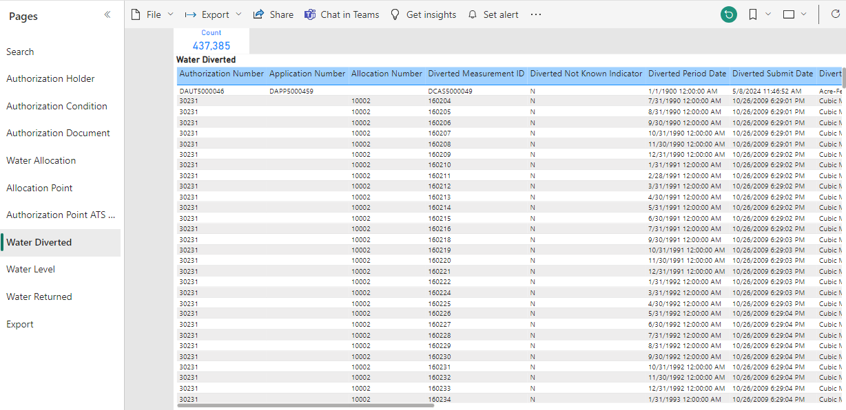

Water Level Page:
This page displays the History of Water Level for the Authorizations over time
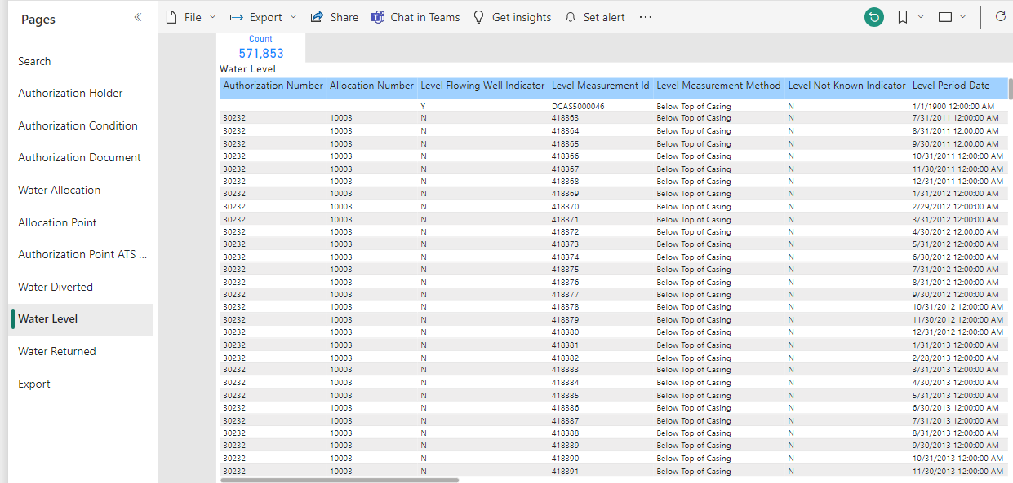
Water Returned Page:
This page displays the History of Water Returned for the Authorizations over time
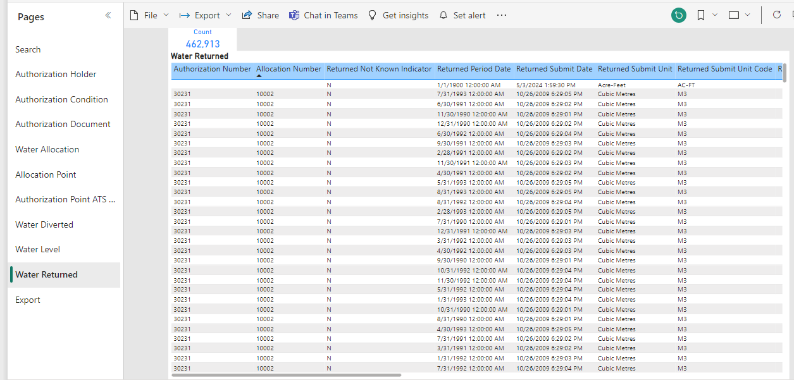

Export Data
Displayed data in the Table can be exported to Excel or .csv file for further analysis. This can be done using the steps mentioned below.
- Hover over the top right of the Report to look for the three dots. Click on the three dots to display the More options.
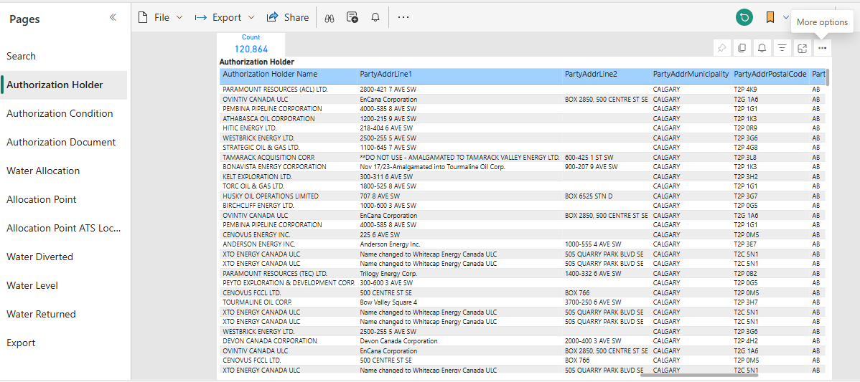
- Click on Export Data
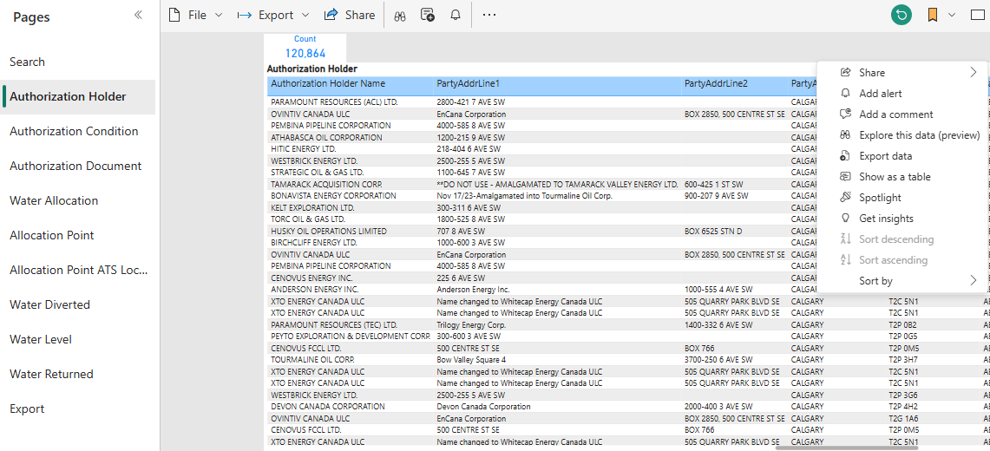
- Select> Data with Current Layout, and then Click on Export.

Water License Level Measurements Report- Water Act
This Report can be accessed in Production environment from the Power Bi Workspace Water Licence Level Measurements - Power BI

Search Filter Parameters

User can search using one or more of the attributes from the Water License Level Filters

- Authorization Number – Text Field
- Authorization Type – Dropdown
- Authorization Status – Dropdown
- Licensee Name – Text Field
- Regulator – Dropdown
- Allocation Purpose – Dropdown
- Allocation Sub Purpose – Dropdown
- Allocation Classification – Dropdown
- Allocation Sub Classification – Dropdown
- Allocation Specific Classification – Dropdown
- Allocation Quantity – Range
- Period Date – Range
Upon selecting one or more search filter parameters, the user must click on button to display the Table of results.
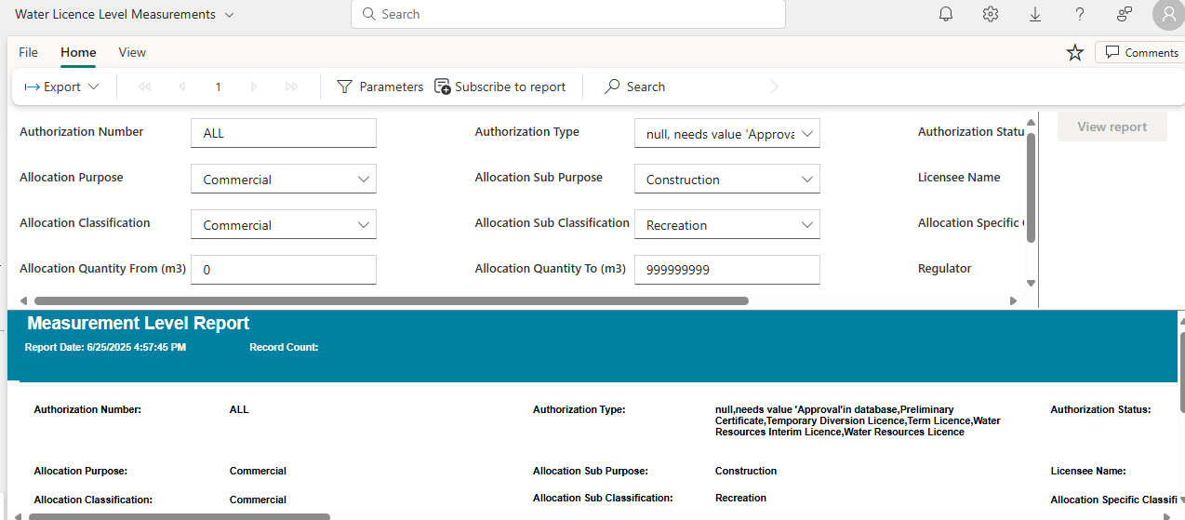

Export Data
Displayed data in the Table can be exported to Excel or .csv file for further analysis. This can be done using the steps mentioned below
- Click on Export Dropdown at the top left> Select Microsoft Excel or Comma Separated Values (.csv)
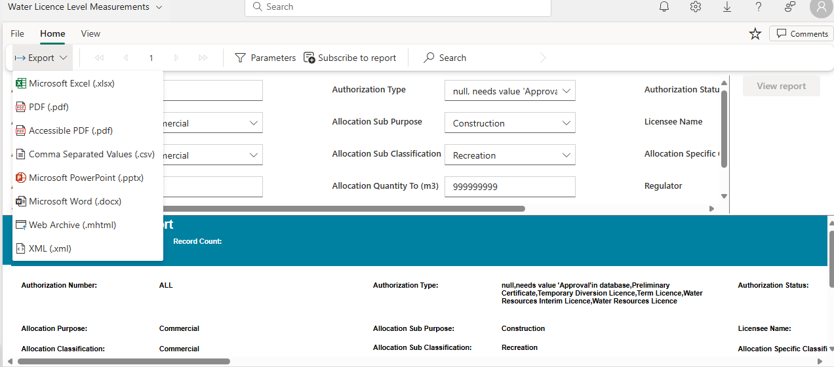

Water License Quality Measurement Report- Water Act
This Report can be accessed in Production environment from the Power Bi Workspace Water Licence Quality Measurements - Power BI

Search Filter Parameters
User can search using one or more of the attributes from the Water License Quality Filters

- Authorization Number – Text Field
- Authorization Type – Dropdown
- Authorization Status – Dropdown
- Authorization Holder – Text Field
- Regulator – Dropdown
- Allocation Purpose – Dropdown
- Allocation Sub Purpose – Dropdown
- Allocation Classification – Dropdown
- Allocation Sub Classification – Dropdown
- Allocation Specific Classification – Dropdown
- Allocation Quantity – Range
- Period Date – Range
Upon selecting one or more search filter parameters, the user must click on button to display the Table of results.
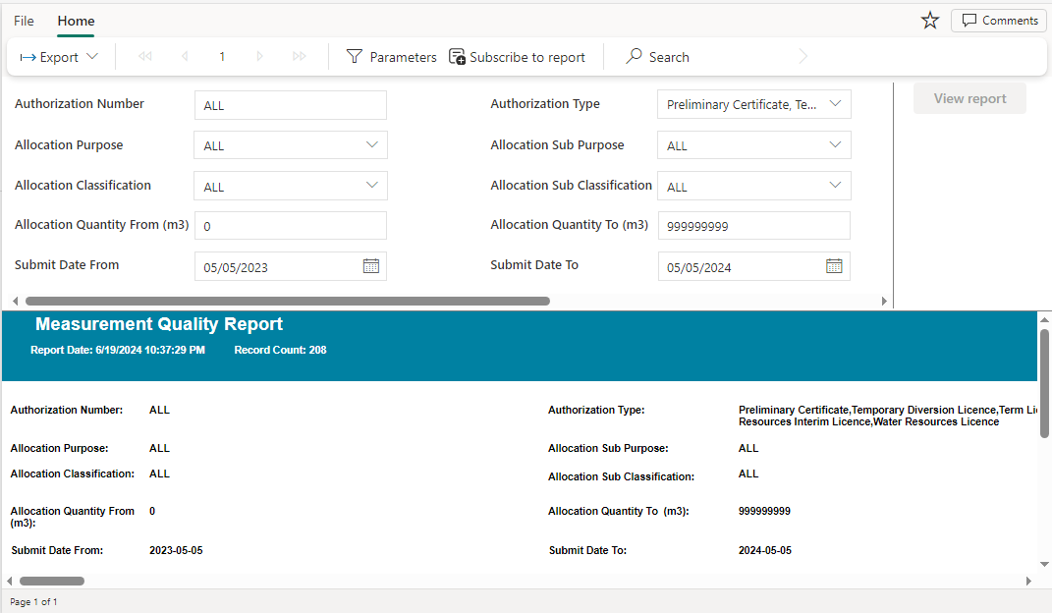

Export Data
Displayed data in the Table can be exported to Excel or .csv file for further analysis. This can be done using the steps mentioned below
- Click on Export Dropdown at the top left> Select Microsoft Excel or Comma Separated Values (.csv)
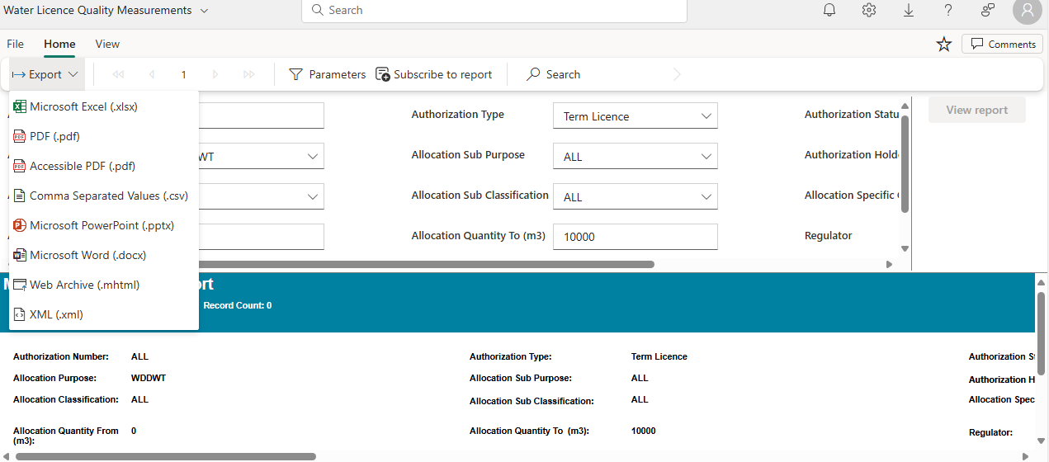

Water License Usage Measurements Report – Water Act
This Report can be accessed in Production environment from the Power Bi Workspace Water Licence Usage Measurements - Power BI

Search Filter Parameters
User can search using one or more of the attributes from the Water License Usage Filters

- Authorization Number – Text Field
- Authorization Type – Dropdown
- Authorization Status – Dropdown
- Authorization Holder – Text Field
- Regulator – Dropdown
- Allocation Purpose – Dropdown
- Allocation Sub Purpose – Dropdown
- Allocation Classification – Dropdown
- Allocation Sub Classification – Dropdown
- Allocation Specific Classification – Dropdown
- Allocation Quantity – Range
- Period Date – Range
Upon selecting one or more search filter parameters, the user must click on button to display the Table of results.
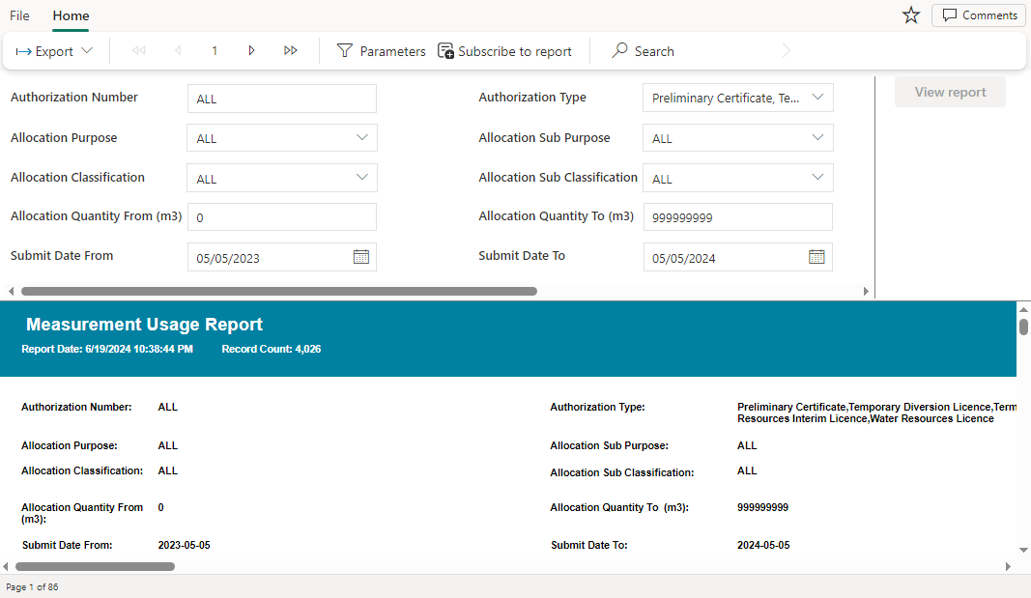

Export Data
Displayed data in the Table can be exported to Excel or .csv file for further analysis. This can be done using the steps mentioned below
- Click on Export Dropdown at the top left> Select Microsoft Excel or Comma Separated Values (.csv)

Help
Do you experience an application or access problem? Contact regulatoryassurance.support@gov.ab.ca

